EXPERIMENT-11
IMPLEMENTATION OF DIFFIE-HELLMAN KEY EXCHANGE
AIM
To implement the Diffie–Hellman key exchange algorithm for securely generating a common secret key between two users.
ALGORITHM
- Choose a prime number p.
- Choose a primitive root g.
- User A chooses a private key a.
- User B chooses a private key b.
- Calculate A's public key: A = g^a mod p.
- Calculate B's public key: B = g^b mod p.
- Calculate the shared secret key:
  - User A: K = B^a mod p
  - User B: K = A^b mod p
- Verify that both users obtain the same shared key.
CODE:
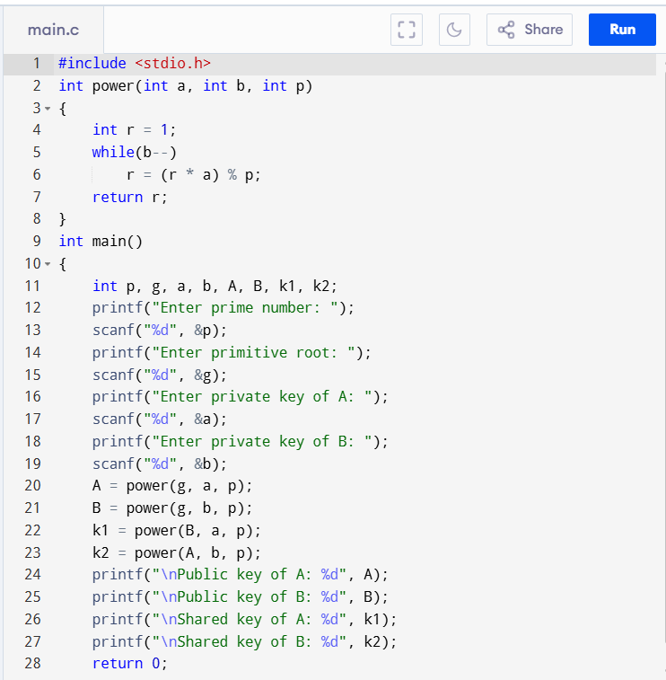
OUTPUT:
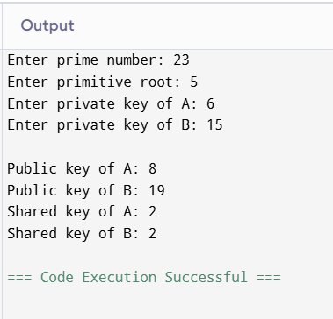
RESULT:
Thus, the Diffie–Hellman key exchange algorithm was successfully implemented, and both users generated the same shared secret key.

